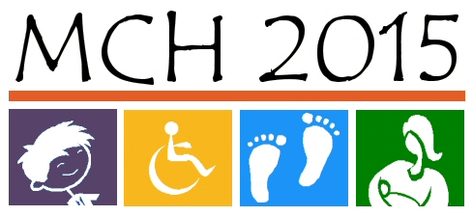
Maternal Child Health 2015
Needs Assessment
Panel of Experts – Session 1

November 6th, 2009

9:00 - 9:30 Check-In and Continental Breakfast

9:30 - 10:30 Plenary Session: Overview of Title V and Title V Needs Assessment

10:30 - 10:45 Break

10:45 - 12:00 Plenary Session: Charge to Group

12:00 - 12:20 Break: Lunch – Please pick up your lunch and break into your workgroups.

12:20 - 1:00 Workgroup Session: Introductory Lunch with Workgroup
- Pregnant Women and Infants Workgroup – Mansion Dining Room
- Children and Adolescents Workgroup – Mansion Gold Room
- Children & Youth with Special Health Care Needs Workgroup – Grand Ballroom

1:00 - 2:15 Workgroup Session: Review Indicator List

2:15 - 2:30 Break

2:30 - 3:30 Workgroup Session: Final Selection of Indicators
Determination of Data Needed for Decision Making

3:30 - 4:15 Plenary Session: Group Presentations (15 minutes per group)

4:15 - 4:30 Plenary Session: Wrap-up and Door Prizes

Next meeting: 9:00 a.m. – 4:30 p.m., Friday, January 29th

